Good evening TSHS Learning Community,
It’s been a positive and productive start to our week at TSHS. Here are the updates and announcements for all students and families.
Congratulations to our band proudly awarded “Bands of America 2023 Regional Grand Champions”!!! We are extremely proud of the success of these amazing students!! Thank you to our Directors, Parent Volunteers and Staff.
Congratulations to our football team! For the first time since 2000, our team is 6 – 1 as we wrap up the season with just a few games left of the season. Thank you to Coach Frioud and his athletic staff!!!
- Here is a positive news segment from WTSP Channel 10 that highlights TSHS: https://youtu.be/emySfRLzj3o?feature=shared

Homecoming 2023
- Please refer to the Student Life tab on the school’s website for all Homecoming event details, participation forms and guest permission forms.
- Ticket sales for our Homecoming dance may be purchased using Revtrack – school’s website homepage, “online payments portal”.

Upcoming Events:
- Pink Out! Oct. 26 *students are encouraged to wear pink
- Report Cards will be uploaded into Focus by Friday, Oct. 27.
- Celebrations for students who proudly earned Principal’s List and Honor Roll are forthcoming. Invitations will be distributed to students within the next week.
- Swim Team – Regional Meet Saturday, Oct. 28
- Outdoor Music Festival Saturday, Oct. 28
- Powder Puff Monday, Oct. 30 *$5.00 donation at entry **proceeds from Powder Puff will support the holiday food basket drive

Chorus Dinner Theater
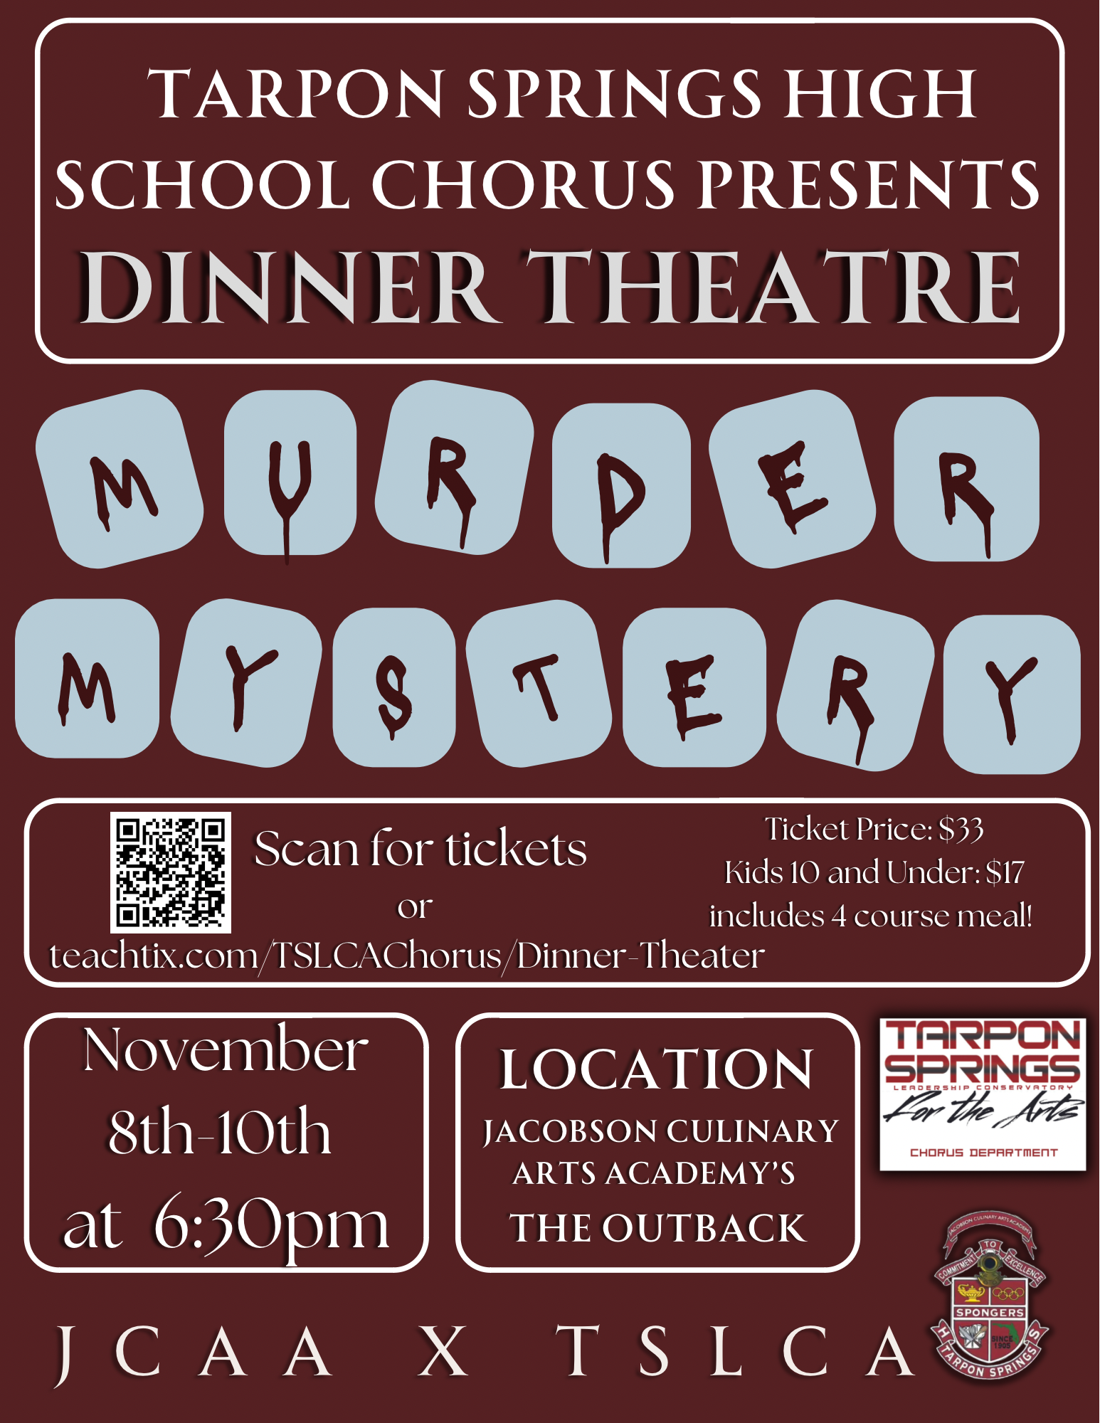
Have a great week!
Mrs. Fatolitis

